# INTRODUCTION

* 1. Overview
  2. The project aim is to provide real-time knowledge for all the students who have basic knowledge of Salesforce and Looking for a real-time project. This project will also help those professionals who are in cross-technology and want to switch to Salesforce. With the help of this project they will gain knowledge and can include it into their resume as well.
  3. A brief description about your project
  4. A school management CRM (customer relationship management) is a software tool designed to help schools and educational institutions manage their interactions with students, parents, teachers, and other stakeholders. With a school management CRM, you can: Keep track of student and parent contact information, including phone numbers, email addresses, and physical addresses Track and analyze student performance and progress Overall, a school management CRM helps to streamline and automate many of the administrative tasks associated with running a school, making it easier for educators to focus on their primary goal of providing a high-quality education to their students.
  5. Purpose Customer relationship management (CRM) is a technology for managing all your company's relationships and interactions with customers and potential customers. The goal is simple: **Improve business relationships**. A CRM system helps companies stay connected to customers, streamline processes, and improve profitability.

The use of this project. What can be achieved using this.

* CRM software allows businesses to manage, analyze and leverage their interactions with customers or potential customers.
* CRMs integrate your customer data into a centralized platform which allows sales teams to manage, analyze and predict the behavior of potential clients.
* Parents and managements are interconnected together using this program
* Communicate with parents through email, SMS, and whatsapp
* Analyze event data and generate reports to track event performance and identify trends

1. **Problem Definition & Design Thinking**

Empathy Map

* 1. 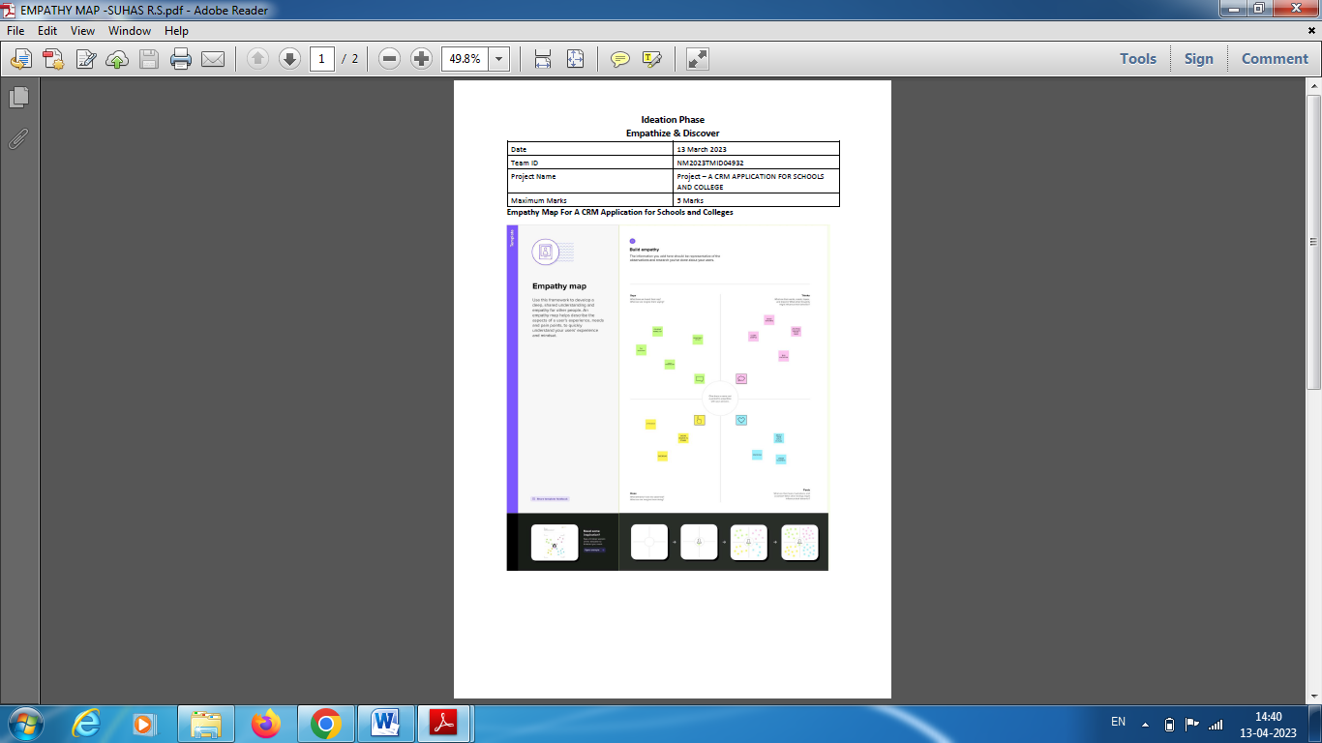

Ideation & Brainstorming Map

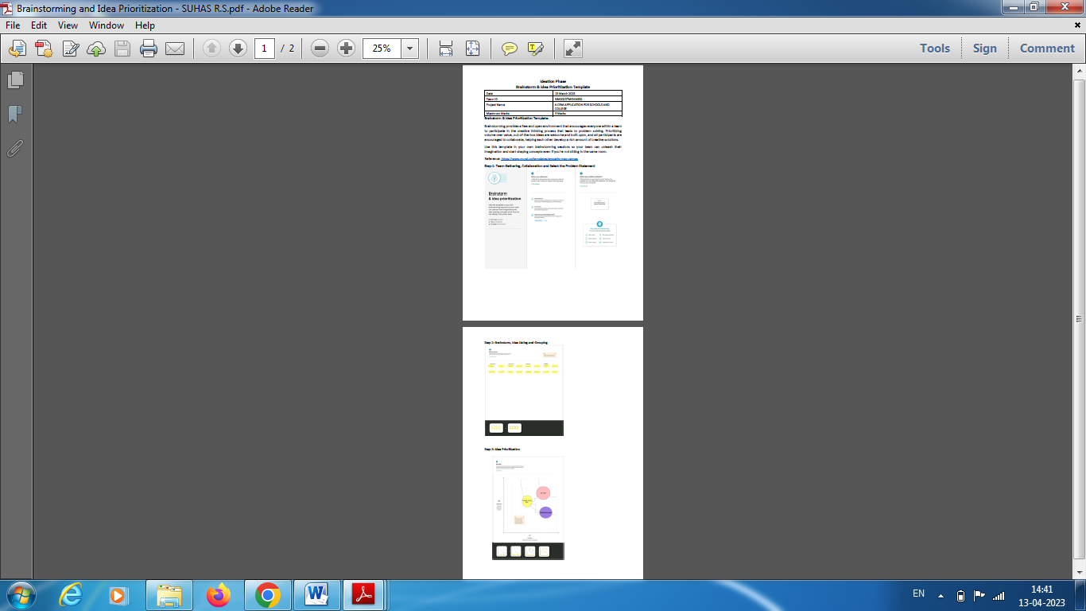

* 1. I

# RESULT

* 1. Data Model:

|  |  |
| --- | --- |
| Field label | Data type |
| Parents name | text |
| Parent number | number |
|  |  |
|  |  |

|  |  |
| --- | --- |
| **Object name** | **Fields in the Object** |
| obj1  parents |  |
| obj2  students | |  |  | | --- | --- | | Field label | Data type | | marks | Number(18, 0) | | results | Picklist | | school | Master-Detail(School) | |
| Obj 3  schools | |  |  | | --- | --- | | Field label | Data type | | School name | Text(80) | | School address | Text Area(255) | |
|  |  |

## Activity & Screenshot

Attach the screenshots of your project activity along with the description.

## Trailhead Profile Public URL

**Team Lead - https://trailblazer.me/id/suhrs Team Member 1 - https://trailblazer.me/id/saras337**

**Team Member 2 - https://trailblazer.me/id/vkumarb9Team Member 3 – https://trailblazer.me/id/sugaa5**

# ADVANTAGES & DISADVANTAGE

List of advantages

* CRM software is used to gather customer interactions in one central place to improve customer experience and satisfaction.
* The benefits of CRM include better customer retention, increased sales and detailed analytics.
* CRM is one of the world’s fastest-growing industries, expected to grow at a rate of 14% between 2021 and 2027.

List of disadvantages

* CRM costs. One of the greatest challenges to CRM implementation is cost. ...
* Business culture. A lack of commitment or resistance to cultural change from people within the company can cause major difficulties with CRM implementation.
* Lack of leadership.

# APPLICATIONS

* CRM stands for “Customer Relationship Management” and is a software system that helps business owners easily track all communications and nurture relationships with their leads and clients
* In universities plan the academic schedules
* CRM can analyze data and generate reports whenever required. There are mainly three types of CRM applications – Operational, Analytical and Collaborative to perform all these activities.

1. CONCLUSION
   1. Customer relationship management (CRM) is a technology for managing all your company's relationships and interactions with customers and potential customers. The goal is simple: **Improve business relationships**. A CRM system helps companies stay connected to customers, streamline processes, and improve profitability.

# FUTURE SCOPE

Customers will become a company's best sales reps through superior products and services as well as customer-oriented messaging. The future of CRM is more than just the future of Customer Relationship Management software. It is really the future of business.